**Changes to hma-pwl-production-v3.1.6**

General

* Import macro updated to support worksheet version V3.1.6 (7-30-2024).

LJ Core Density Pay Adjustment

* FIX: Fixed a bug that incorrectly incentivized unconfined joints that were more than 1.0% (instead of 2.0%) greater than the minimum requirement.

LJ Nuc Density Pay Adjustment

* FIX: Fixed a bug that incorrectly incentivized unconfined joints that were more than 1.0% (instead of 2.0%) greater than the minimum requirement.

**Changes to hma-pwl-production-v3.1.5**

General

* Import macro updated to support worksheet version V3.1.5 (7-25-2024).

LJ Nuc Density Pay Adjustment

* FIX: Fixed a bug that caused a DIV/0 error in the pay adjustment when there was a non-comparison and the analytical sublot did not contain a QV test result. This behavior has been reverted to use QC results when there is a non-comparison and there is no QV test result in the analytical sublot.

**Additional Guidance for Enabling Macros in Microsoft Excel**

As of February 23, 2023, Microsoft has blocked macros by default from spreadsheets downloaded from the internet (aka Pantry) to provide additional protection from malicious macros. When this occurs, you will see an error like this at the top of the spreadsheet:



When this error is presented, you will be unable to enable macros using old methods where you could simply click the button in the banner to enable macros. Additional steps are required to enable the macros. Please perform the following steps to enable macros:

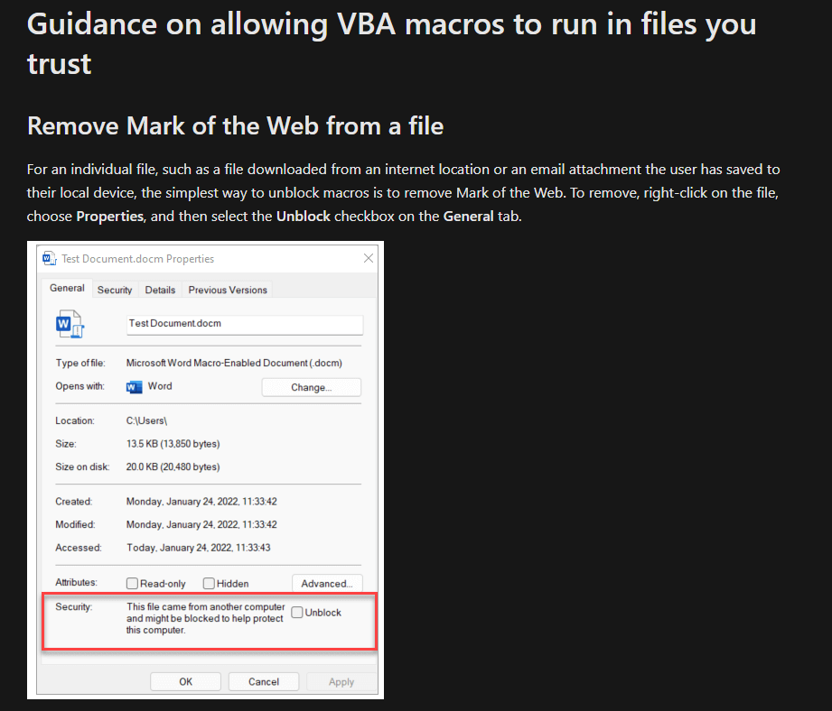

Additional information about this change can be found on Microsoft’s website at:

<https://learn.microsoft.com/en-us/deployoffice/security/internet-macros-blocked>

If you have any additional questions or issues running macros in your worksheets, please reach out to:

[albert.kilger@dot.wi.gov](mailto:albert.kilger@dot.wi.gov)